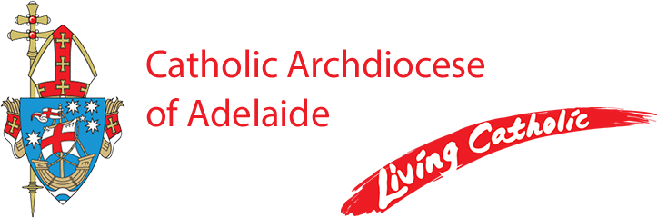

Parish Secretary
Brighton Parish

Part-time, 5 days per week (25 hours) Monday - Friday
The Brighton Parish is seeking a highly motivated and suitably qualified Parish Secretary to join their Parish Team.
The successful applicant will be experienced in providing excellent office administrative support and be competent in using the Microsoft Office suite.
Excellent interpersonal and communication skills are essential together with the ability to work in a team environment.
The successful applicant will be strongly committed to the Catholic ethos.
A copy of the Position Description can be obtained by emailing Michelle CIni, HR Advisor
at recruitment@adelaide.catholic.org.au
Applications should be forwarded to the Parish Priest, Fr Michael Kyumu at bm@brightonparish.com.au
by 5pm on Monday 06 May 2024
Employment with the Catholic Archdiocese of Adelaide is conditional upon a successful Working with Children Clearance and successful reference checks.
The Catholic Archdiocese of Adelaide is an Equal Opportunity Employer and a Child Safe organisation.

